Emma’s visit to London.

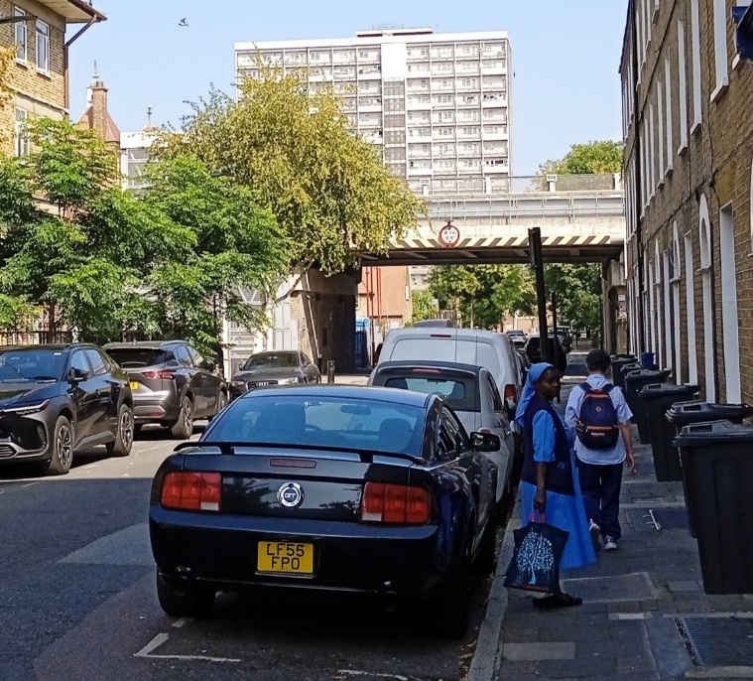
We are so happy to welcome Little sister Emma Bolang who is from English speaking Cameroons, to join our communities in Britain for two years. Emma was invited by Bishop Collins of East Anglia so she will join the little sisters in Walsingham, a little village in Norfolk where the National Shrine to Our Lady is situated. The Shrine dates back to 1065 and became a focal point for devotion to Mary with pilgrims arriving from all over Europe.

Emma came to stay with Emiko and Catharine in Hackney for ten days and enjoyed so much visiting London: Big Ben, the Houses of Parliament and the Abbey and the Catholic Cathedral of Westminster, Buckingham Palace and Trafalgar Square but her favourite was the London Eye!

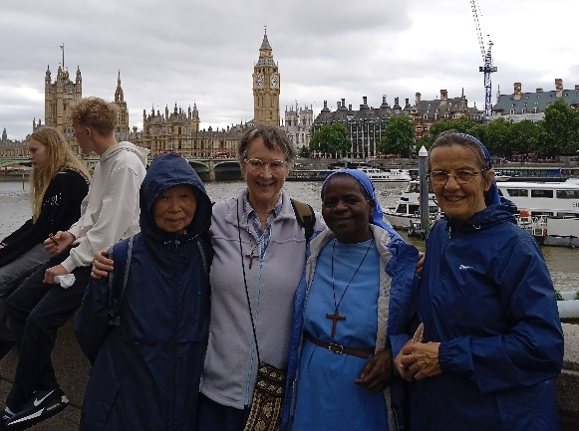
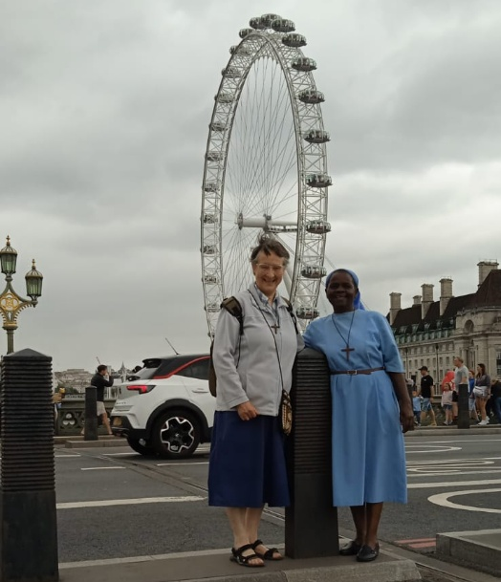

Cathy and Emiko also took her to see the monument to the great fire of London and to walk along the Thames to the Tower of London and to see St Catherine Docks.

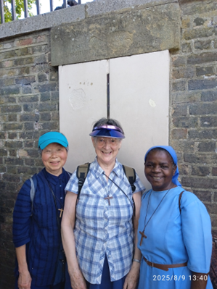
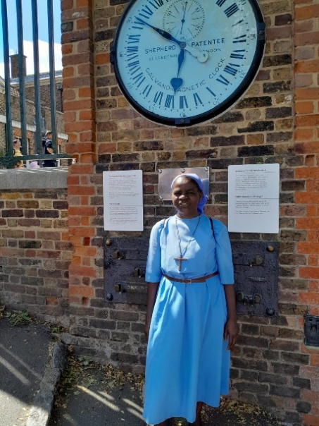

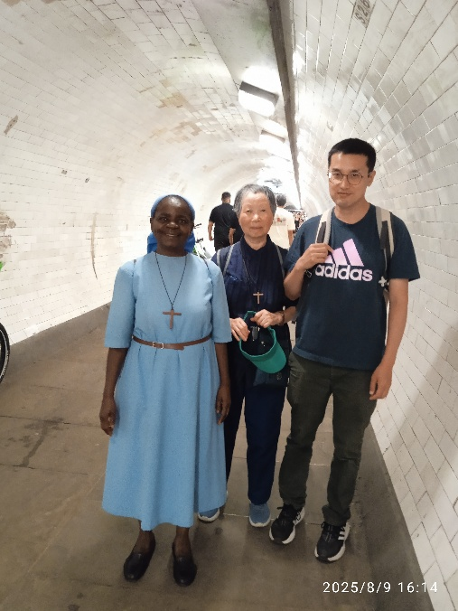
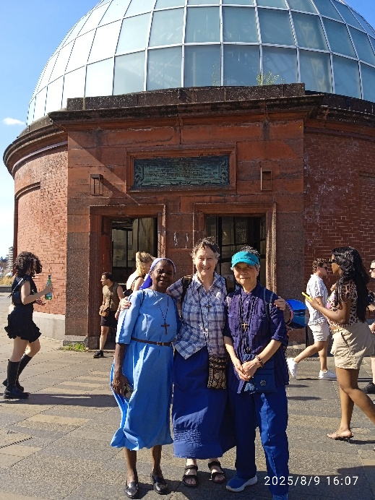
We also went to Greenwich to stand on Meridian 0 and to visit the Maritime Museum and the Cutty Sark and to walk under the Thames to Island Garden.

Emma was impressed by the number of tourists speaking every language…! ‘This is really the City of London’ she said, ‘but Hackney is like my village. ‘There we greet everybody and stop for a chat with every passer-by. I love the atmosphere. It is really like home in the big social housing tower block where the Little sisters live on the 13th floor. I see everyone there is very preoccupied by the need for repairs, but all the problems seem to have brought people together, caring for each other from every background and religion.’

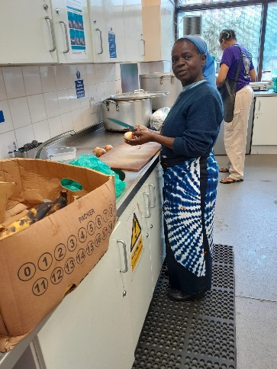
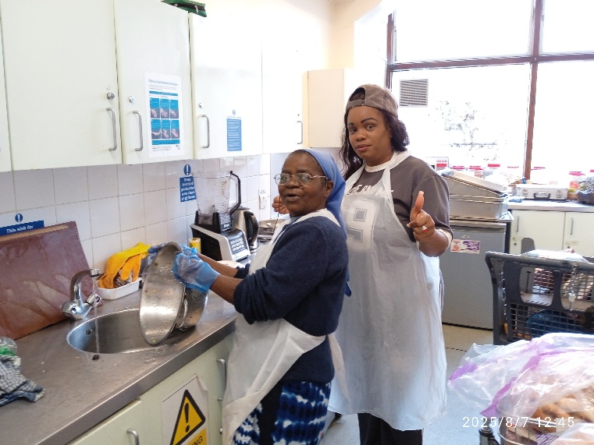

I was able to help at the local Soup kitchen three times during my stay. I was so lucky too to be invited for a party for volunteers who give their time and energy to work there. What a wonderful initiative! Everyone, whoever you are is made so welcome. If I could live in two places at once I would ask to come to Hackney and work at the soup kitchen.
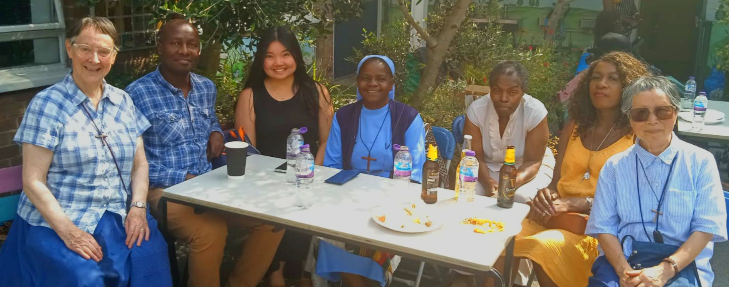

I also loved the Little sister’s parish of St Monica. There too I was made to feel quite at home. Father Gabriel, the Parish priest is from Nigeria as are most of the parishioners. Sometimes I had to pinch myself and say: “Am I in Africa!”. I could even join in the party, African style, given for those who help out in the parish.
I also enjoyed going to Dalston market where you can buy all sorts of African and West Indian food and other products. I bought Okra and Fufu and could also find what I needed for my hair.
Yes, I felt very welcome and at home in Hackney and was so often invited to stay, but I am also very at home in my new little village of Walsingham and I am very happy to live there among all our lovely friends.’

